Teaching plan
Teaching content: PEP6上 Unit3 My weekend plan
B Let’s learn
倪 青
Ⅰ、Teaching aims:
1.Knowledge aims:
To listen、speak、read and write the key words:postcard,word book,comic book,dictionary.
To understand and read the key sentences:Where are we going?What are you going to buy?I’m going to buy....
2.Ability aims:
To talk about what you are going to do with your partner.
3.Emotion aims:
To understand and know reading is a good habit and we should keep reading every day.
Ⅱ、Teaching focus:
Teaching importance:
To know and grasp the key words and the sentences.
Ⅲ、Teaching difficult point:
To work in pairs to ask and answer the questions about what and where they are going to do.
Teaching aids:
word cards
CAI
Bb
Ⅳ、Teaching period:
40 minutes
Ⅴ、Teaching activities:
Stage 1: Warm up
1.Greetings
2.Warm up
Sing a song What are you going to do togehter.
Stage 2: Presentation
1.Let’s guess
Look! T：“Who is she?(出示我的照片) Yes,it’s me.Can you guess where I am going?”
Let’s guess a riddle.
*It’s a building.You can buy books here.Where is it?
(出示答案、图片：The bookstore)
2.Let’s learn
I’m going to buy some books in the bookstore this weekend.Can you guess what am I going to buy?
Show a picture of postcard,and ask“What’s this?”,then teach the new word.Then teach other words in the same way.
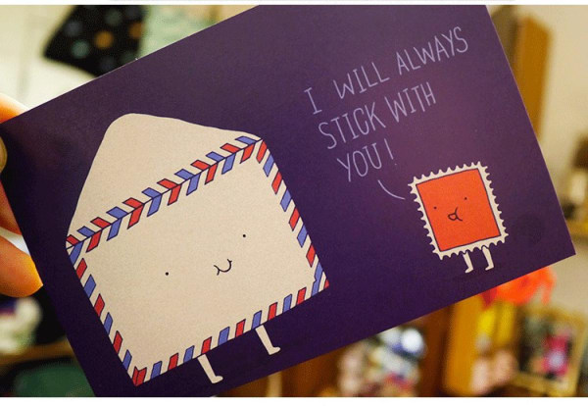
Post,post,a postcard;
Posts,posts,some postcards;
I’m going to buy some postcards.

(目标：To know and teach the new words about book.)
3.Sharp eyes
Show the pictures of the words quickly,and ask the Ss to read the words one by one quickly.
(目标：To read and practice the new words.)
Stage 3: Practice
1.What’s missing?
Show the Ss’ the pictures and cover one,then ask the Ss to find and read the word correctly.
（目标：To consolidate and practice the new words.）
2.Ask and answer
Look at the picture of a bookstore and learn the short dialogue.Then practice the structures.
*-----What are you going to buy?
-----I’m going to buy a/an....
*-----What are you going to buy ?
-----I’m going to buy some ....
(本次练习注重考查学生对于名词单复数的掌握与练习。)
Stage4 Consolidation
1.Read and answer
Read a new short passage,and then answer a question:What’s Liu Yun’s plan?
- Fill in the blanks
Read the passage and fill in the blanks .(目标：To consolidate the structures and practice the Ss’ ability of reading.)
2.Let’s enjoy and sing
Show the Ss some pictures of famous books and enjoy.
(目标：To know some more great books and know reading is a good habit,we should keep reading every day.)
Then sing a song what are you going to do together.
Stage 5: Homework
1.Read and copy the new words and the structures.
2.Talk with your friends about what you are going to do and make a weekend plan.

Bb design:
Unit3 My weekend plan
the bookstore

postcard
word book
comic book
dictionary

---Where are we going?
---To the bookstore,
---What are you going to buy?
---I’m going to buy a new comic book.

